My name is Ekaterina and I‘ve been testing the 8base Quick Start page (using Windows and Google Chrome). There are **some bugs** I’d found (screenshots attached), in chronological order:

1. **INCORRECT POINTER**

In chapter 2.1 pointed that button named [+Create Table] while in the app it named [+New Table]

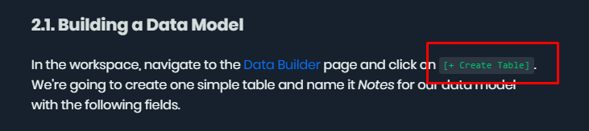

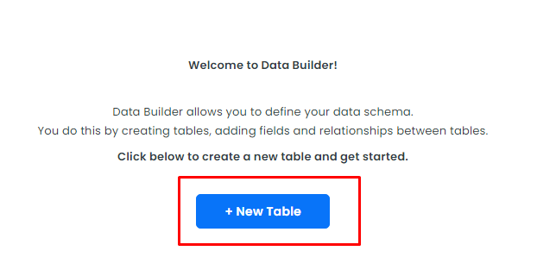

Expected: same button on the screenshot and in the app.

How to see this bug:

Workspace -> Data Builder and Quick Start chapter 2.1.

1. **INCORRECT SCREENSHOT ATTACHED**

In chapter 2.1 mentioned flag True on multiple Notes per User, but on the screen below marked checkbox with multiple Users per Note:

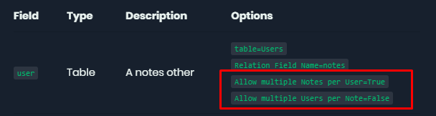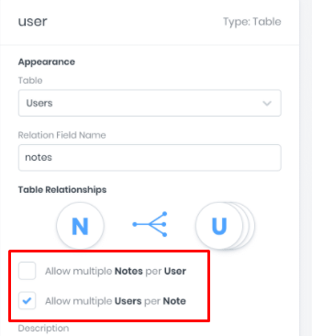

Expected: description and screenshot will be the same.

How to see this bug: open Quick Start chapter 2.1.

1. **UNEXPECTED TABLE**

In chapter 2.2 no information about table “Invoices”, but this table appears on the picture below. There are two screenshots: first from guide, second is mine in role editing mode:

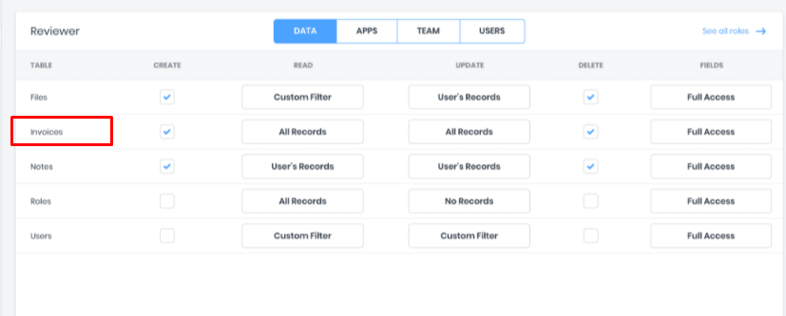

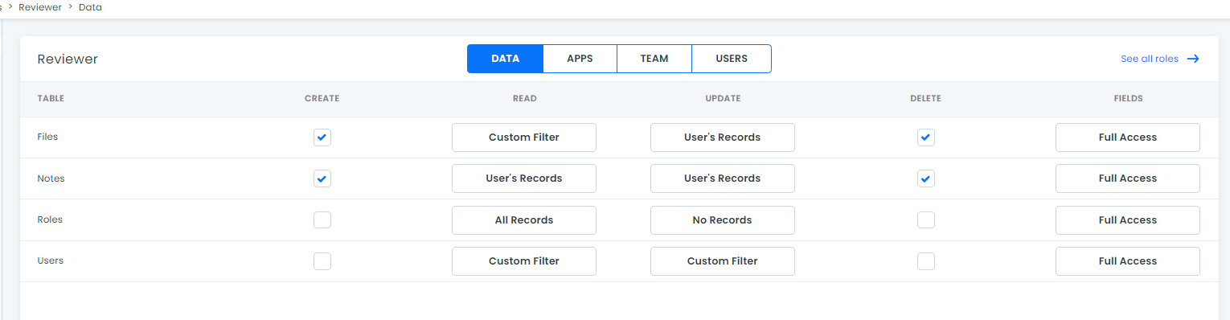

Expected: all tables on screenshot will match the real ones (in the app).

How to see this bug:

Workspace -> App services -> Roles -> Reviewer and Quick Start chapter 2.2.

1. **SYNTAX ERRORS (NOT CRITICAL)**

In chapter 2.3 on the attached screenshot value for Name “Default Guest Auth” is in quotes while other values are not. And one more thing, I don’t know if it’s important, but in auth.profile window value “8base Authentication” the word authentication starts from big A, while in guide it starts with small a:

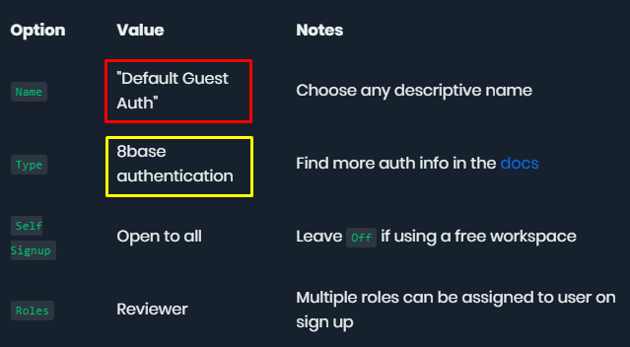

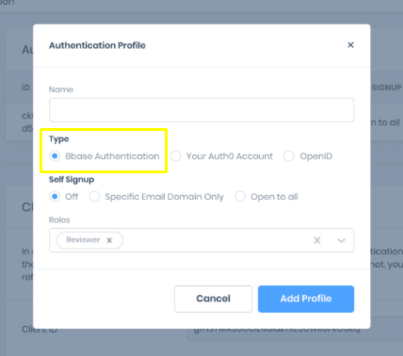

How to see this bug: open Quick Start chapter 2.3.

1. **INCORRECT COMMAND**

In chapter 3 command “mkdir 8base-starter-app 8base-starter-app/client 8base-starter-app/server” doesn’t work with args properly (on the picture said that it can’t find positional parameter for arg “8base-starter-app/client):

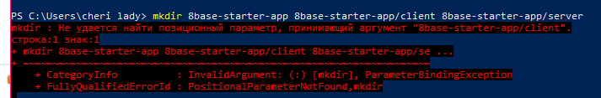

Expected: command will create directory without throwing errors.

How to see this bug: write in console command from the screenshot.

1. **NON-COPY TEXT**

In chapter 3 (and later 3.1), again, you can’t copy some of the commands (marked):

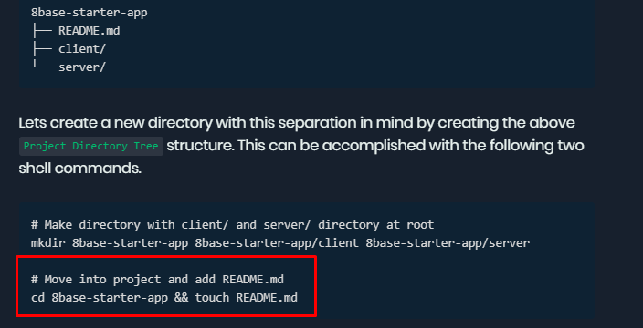

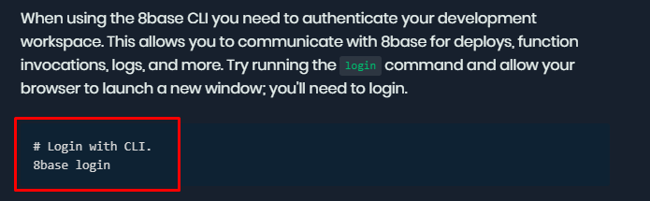

Expected: user will have the ability to copy necessary commands from the Quick Start guide.

How to see this bug: open Quick Start chapter 3 and 3.1.

1. **INCORRECT COMMAND**

In chapter 3.2 while running command 8base init . --functions=resolver:myCustomResolver “error: Invalid project name: name cannot start with a period“ appears. In example not mentioned that you should name the project, but actually it is required (as I understood, in other way It doesn’t work). Another one error is also connected to project name - “Error: Invalid project name: name cannot be undefined”.

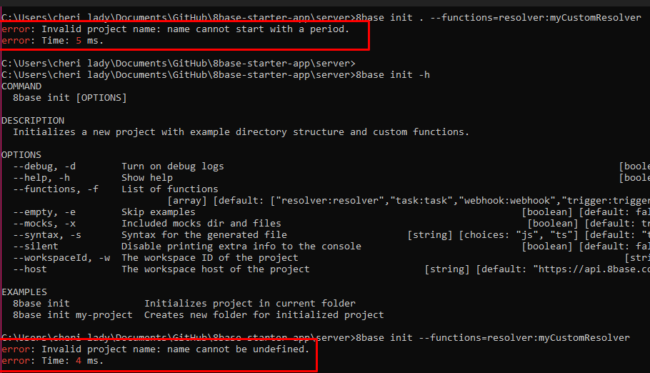

Expected: project will be made without errors.

How to see this bug: cmd -> write command above -> run and Quick Start chapter 3.2.

Way to solve:

There is alternative command where our project has name:

..\8base-starter-app> 8base init server --functions=resolver:myCustomResolver

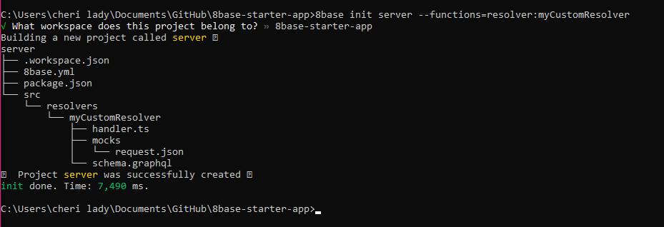

1. **COMMAND IS REQUIRED**

In Quick Start all commands were highlighted separately, so user understands that he should run them in command line. But in chapter 3.2 “deploy” command marked as introductory (by running the 8base deploy, etc.). Probably, user will recognize it as recommendation, not as instruction, while “deploy” is *essential*.

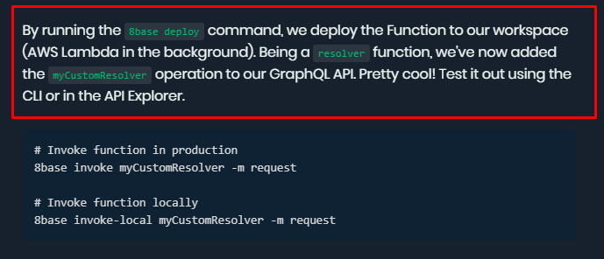

Expected: command “deploy” indicated separately as other commands in Quick Start.

How to see this bug:

cmd -> run command 8base invoke WITHOUT deploying and Quick Start chapter 3.2

Way to solve: run “deploy” command before “invoke”.

1. **SIGN IN DOESN’T WORK**

When running the app and click button “Sign in”, page responses an error:

“Client ID invalid request: error=invalid_request&client_id=33nl8rjq896k3fif7omdtsempc”. But all environment variables are copied correctly. Here is also the screenshot from devtools:

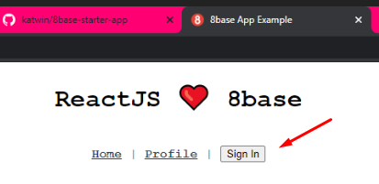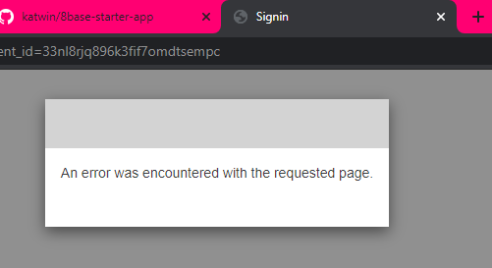

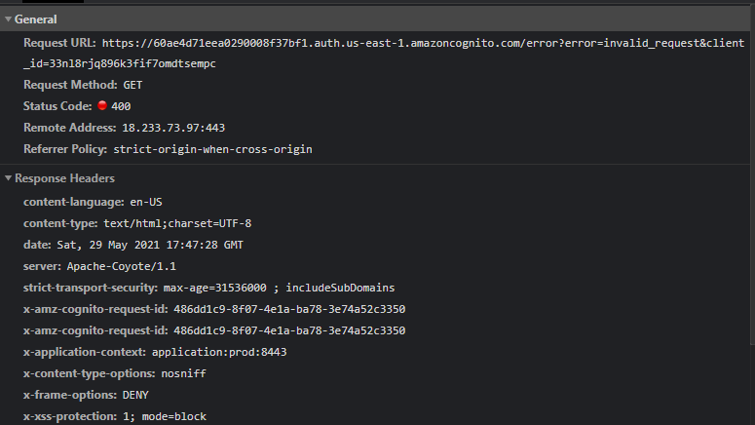

Expected: Sign in page will appear after clicking eponymous button.

How to see this bug: run the app and click on “Sign in” button

Also there are some things I mentioned not as bugs but as **feature requests**:

Screenshots attached to Quick Start chapters not always correctly positioned. For example, chapter 2.3:

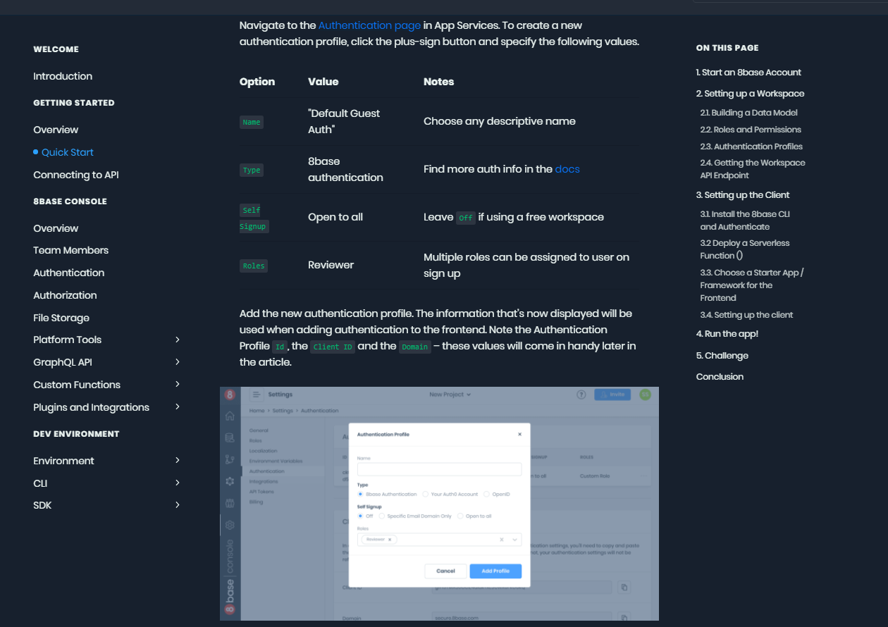On the picture above firstly explained how to fill the information in auth.profile window, then some other info about ID, Domain, etc. And only after that we see screenshot with auth.profile window as a visual demonstration. Maybe will be better to place this screenshot right after the filling instruction.

1. Text is readable, but pictures are ‘unclickable’. So when you’re trying to see the picture closer, you have to zoom the whole page and then zoom it out, and doing it often can be very uncomfortable.
2. Some of links at Quick Start are unclickable, too.
3. In chapter 3, 3.1, etc. not mentioned where exactly console commands should be entered. I mean, I’ve been trying to write them in Windows PowerShell and some commands from the guide didn’t worked. For example, there is no command “touch” in PowerShell, and user should have some skills to know similar commands to get the result.
4. About command “npm install” in client: when adding all packages, console gives an error message about a lot of vulnerabilities. Don’t know if it is necessary, but will be there for information.

